OVERHAULING,REPAIR & TRIAL OF MOTORS

Objective : Overhauling, repair and trial of motors

Scope : All LT and HT electrical motors

Ref : Motor manufacturers manual.

- Aspect: Waste generation
- Impact: Resource depletion
- Hazards: Noise generation, Fumes and vapours while varnishing winding. Falling of object on person, cut of human body parts due to sharp materials, Electrical shock, hazard due to moving parts while taking no load trial on test bed.
- Behavorial Hazards: Taking trail of motor- 1) without motor barrication ( protection cage), 2) Without removal of motor half coupling and coupling key, non usage of motor shifting rod, EOT crane, trolley for motor shifting, usage of wrong grease during motor assembly.

OVERHAULING OF LT MOTOR

- Bring the motor to the electrical Workshop / CAT DG room (by PALFINGER/HIAB) if large motor or by trolley if small motor), if space is not available at site to open the motor.Clean the motor with compressed air outside CAT DG house before entering inside. do not use compressed air for cleaning over body. Hydra should not be used for pick and carry. Motor should be lifted by using special rods only, which are kept at tool room
Responsibility: Electrical Engineer, Electrician and fitter

- Check the stator insulation resistance before opening the motor.
Responsibility: Electrical Engineer and Electrician

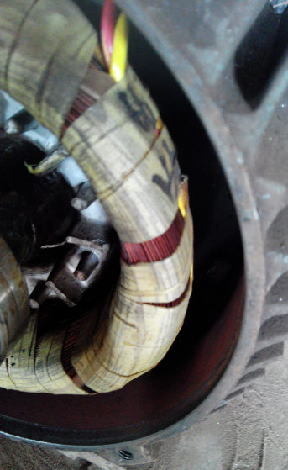

- Open the motor end shields after removal of fan and coupling. If the end shield is not coming out freely, do not use gas cutting set for heating the end shield. If required send the motor to third party for removing the end shield. If heating method is applied for loosening end shield, the residual flammable vapors inside the motor can get ignited and explosion.
Responsibility: Electrician and fitter

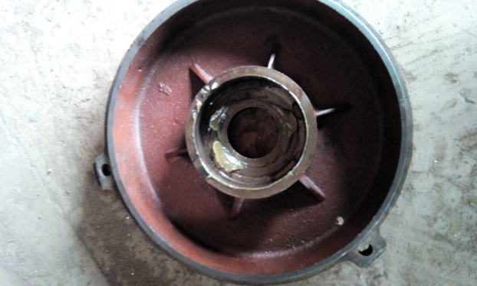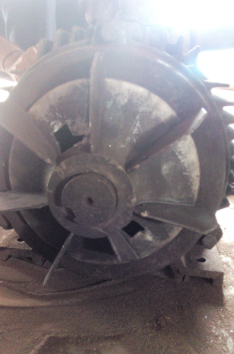

- Check the end shields for scoring & both bearing housing dimensions. If scoring marks are there or bearing fits loosely in housing, send the end shield for re-building or replace it.
Responsibility: Electrical Engineer, machinist and fitter

- Wash the bearing with diesel, check the play and replace if damaged after packing with grease. If overhauling is being done after three years, change the bearings straight away. Bearings should be heated with induction heater only. On history card, PO reference number of bearing replaced shall be written.Before changing the bearings check the clearnce between rotor shaft and bearing ID and available clearance shall be 0.While assembling the slipring motor it has been ensured that the brush holder is aligned in such a way that the brushes are positioned at the centre of the slipring,deviation if any to be corrected for acheiving desired position carbon brush.
Responsibility: Engineer and Fitter
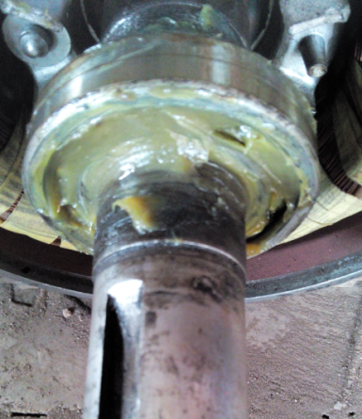

- Clean the winding overhang with Electrosol spray, heat the stator/rotor winding by heater/halogen lamp, then apply air drying varnish (Dr. Beck $ Co.) and again heat the stator till the varnish gets dry. Then apply final coat of Bectal Red varnish. Varnish shall be checked for expiry date. After final drying, its insulation resistance should be measured with 500V Megger for LT motor and 5KV for 11KV HT motor which should be minimum 5 Mega ohms.
Responsibility: Fitter & Electrician
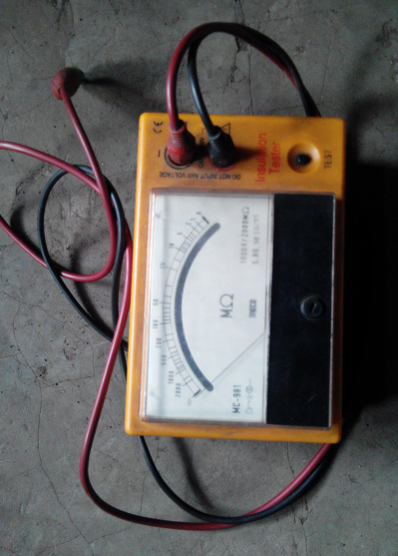

- Grease way/pipe is to be cleaned properly ensuring no dust particle in that. Grease nipples are to be present with the motor. Then assemble the motor. Ensure that bearings are fitted properly both on the rotor shaft & end shields. Shift the motor to test bed & tightened properly the base bolts. Proper nut bolts with washers are to be used according to the motor frame size. Take trial on test bed and run for minimum 2 hours and tag it with full details as written on the readymade test certificates. While taking trial without half coupling, ensure that the motor shaft key is removed and nobody is standing around, and protection cage is placed around the motor which is kept for trial. While taking trial of unbalance motors, those should be kept running continuously for minimum 4 hrs till both side end shield temperature gets stabilized.
Responsibility: Electrical Engineer, Electrician and fitter
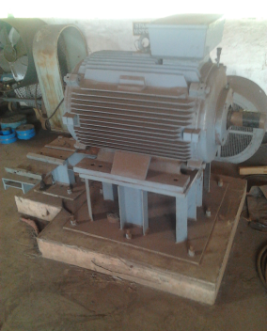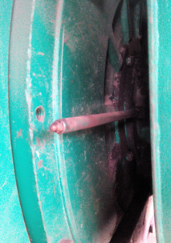

- While connecting the cable to motor terminals, ensure that plug top is not connected to the socket. Check rotation of rotor for smooth movement by moving manually by hand before starting electrically. Main MCB should be OFF while putting plug top to the socket. While putting On the motor alert all the people present around the motor. Ensure double earthing is connected to the motor. While taking slipring motor trial, rotor terminals are shorted at the terminal box.
Responsibility: Electrical Engineer, Electrician

OVERHAULING OF HT MOTOR

DISASSEMBLY OF MOTORS
Responsibility: Electrical Engineer, Electrician and fitter
Before opening the motor discharge the motor terminals using certified earth discharge rod

- Take out half coupling of motor shaft with the help of puller. If the coupling is too tight, coupling may be heated by using gas cutting set. While heating motor shaft should be cooled by pouring water on it to prevent expansion of motor shaft.
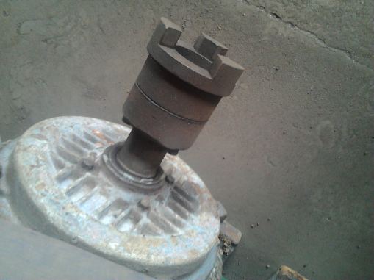

- Take out grease collector on NDE, remove the fan cover and fan. Unscrew the grub screw provided on the external fan hub and pull the hub by jacking through holes provided on the hub. Take out the re-greasing pipe. Remove all the bolts of the end shield. Screw in two long bolts on the tapped holes provided in the end shield and tighten them equally until end shield comes off the spigot and the bearing. If the end shield is not coming out freely, do not use gas cutting set for heating the end shield. If require send the motor to third party for removing the end shield.
Unscrew the two grub screws provided in the centrifugal disc and pull it out with the puller. Now remove the bearing along with inner bearing cover and labyrinth by applying pressure on the labyrinth ring only.

Grub Screw

Holes on the Hub
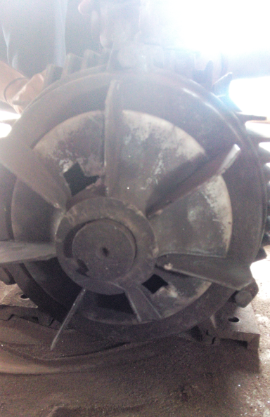
- Similarly remove the bearing on the driving end, except that centrifugal disc must be removed before removal of end shield. This is because the end shield comes out with the outer race cage and the rollers of the bearing. DE bearing is of roller type.
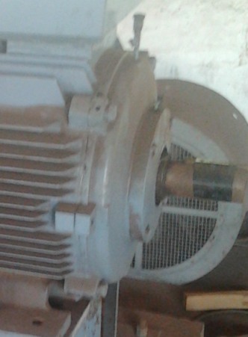

- Insert a long pipe of suitable dia which fits the shaft at the non driving end and pull out the rotor carefully from the stator towards the driving end using double sling with the help of crane. Removal of rotor shall be carried out under close supervision of engineer Incharge.

REPLACEMENTS OF BEARINGS
Responsibility: Electrical Engineer and fitter

- Whenever the bearings are replaced care should be taken to see that only genuine bearings are used to avoid problems associated with spurious bearing. To ascertain whether the bearings are genuine the dimensions like diameter and width should be measured and checked to see if they are within the tolerance limits as specified in the bearing catelogue (If bearing is having a smaller width than specified, then there is every possibility of vibrations developing in the motor.). Bearings are to be heated with induction heater upto a temperature of 85 º C .Use handgloves while handling bearing. After fitting the bearings on shaft, let it cool down, apply lithium based grease, i.e. Lithon/ balmerol – 2 for NGEF/ BBL/Kirloskar/ crompton make motor and lithon/ balmerol 3 grease for siemens and simo make motor. Usage of wrong grease can damage the motor bearings due to improper lubrication. Before changing the bearings check the clearnce between rotor shaft and bearing ID and available clearance shall be 0.

Reconditioning of stator
Responsibility: Electrical Engineer and Electrician .

- Reconditioning of stator is required if motor has clocked 20000 hours of running or motor is in operations for 03 years or winding insulation value is less than 5 M-ohm inspite of heating.
- Clean the stator thoroughly with electrosol spray.Heat it up with the help of halogen lamp or heater for 3 hours. Apply Dr. Beck make F class air dry varnish with the help of brush. Again heat it up for 3 hours.
- Check the meggering value between body & winding and winding to winding, it should be minimum 5 M-ohms. If value is less than 5 M-ohm inform Manager Incharge.
- Clean the stator stamping with the scrapper. Now motor is ready for assembly
- Check rotor throughly for any rotor bar crack,check rotor cooling fan grub screw for proper mounting of fan.

Reconditioning of MOTOR END SHIELDS
Responsibility: Electrical Engineer and Fitter .

- Reconditioning of end shields is required if housing clearance for respective bearing is not allowable as per the particular bearing make booklet.
- End shields are to be sent to third party for reconditioning along with the bearings.
- While receiving the end shields from the third party after reconditioning, housing clearance to be checked with close supervision of the engineer. Also bearing fitting to the end shields is to be checked.
- Unbalance motor enshields shall be directly replaced by new spare ones.
ASSEMBLY OF MOTOR
Responsibility: Electrical Engineer, Electrician and fitter

- Insert the rotor in the stator after thoroughly cleaning the stator and rotor.While inserting the rotor care must be taken to see that the winding over hangs are not damaged. Insertion of rotor shall be done with close supervision of engineer incharge

- Assemble DE bearing sleeve first on the driving end, warm up the labyrinth ring slightly and mount it on the shaft.Next insert the inner bearing cover in position. Cold press the outer race along with cage to the DE end shield and mount the end shield. Fix all the screws properly, warm the centrifugal disc, mount in position and fix the grub screw. Fix the outer bearing cover and tighten the screws. Now fix the grease pipe and grease collectors. To verify healthiness of greasing arrangement, inject the grease by using grease gun and by rotating the motor shaft by hand. All the fixing bolts shall have spring washers.Endshield mounting bolts shall be mounted with a torque range as per the torque table given below.

- On non driving end fix inner bearing cover, ball Bearing, centrifugal disc, end shield, outer bearing cover, grease pipe,external fan hub, fan, fan cooler and grease collector in sequence. While fixing the fans on the shaft, the hole on the fan hub must be brought in line with shaft holes.Ensure that the direction of the fan is correct as per arrow mark shown on shaft. Ensure that the star locking washerconcave side is not facing towards bearing.

- Take trial of motor on foundation without half coupling and note down the vibration readings, if results are ok ,take trial with half coupling fitted on the motor and then give clearance to mechanical for alignment. Before taking trials bearing temperature sensors ( BTD) and winding temperature sensors( RTD) are to be taken in line . Double earthing of motor has to be connected. Ensure correct rotation of motor during trails . Motor terminal stud thread to be checked for proper threading and should have only brass nut.

- Motor shall be shifted at spare motor ready for use area only after the succesfull trail and teasting tag duly signed by the testing Engineer as well as area Engineer( motor overhauling)

MOTOR OVERHAULING /REPAIR/REWINDING AT THIRD PARTY
Responsibility: Electrical Engineer

- Any motor which is required to be sent to third party for overhauling, repair or rewinding etc, shall have an authorisation from motor overhauling in-charge.
- Motor overhauling in-charge, if require shall consult workshop in-charge/HOD, for taking such decision of sending motor to the outside party.
- Details of jobs to be carried out on the motor are to be communicated to the service provider in written through delivery note./ e- mail.
- In case if service provider informs that some additional job is to be carried out, such as bearing replacement, end shield reconditioning etc, which is in addition to the job what was communicated at the time of sending the item, same shall be discussed with workshop in-charge/HOD before giving goahead clearance to the service provider. If any spares are required for the additional job, then availability of those spares shall be cheked in our stores and the same shall be used for the job.
- While taking delivery of the motor from service provider workshop, old replaced items as well weight of scrap copper returned to be witnessed by person taking the custody of material from SP place., Later copper scrap brought is to be returned to store duly weighed. Aknowledgement copy from stores towards the qty of scrap copper returned to stores,delivery note sent by us to SP & D note sent by service provider to us has to to be maintained in respective D note files, duly signed by the respective party.
- After receipt of motor, motor shall be inspected thoroughly like tightening of end shield bolts, bearing end covers, cooling fan, fan cover, terminal box cover, slip ring assembly etc.
- Run the motor for 2 hours or till the body temperature gets stabilized.

Prepared By:  Head – Electrical & Instrumentation PID1 | Reviewed & Issued By:  Management Representative | Approved By:  Head – Electrical & Instrumentation VAB
Signature: | Signature: | Signature:
Date:31.12.2021 | Date: 31.12.2021 | Date : 31.12.2021

